--1. Check: how many rows have Electric Range = 0 (likely missing, not real zero)
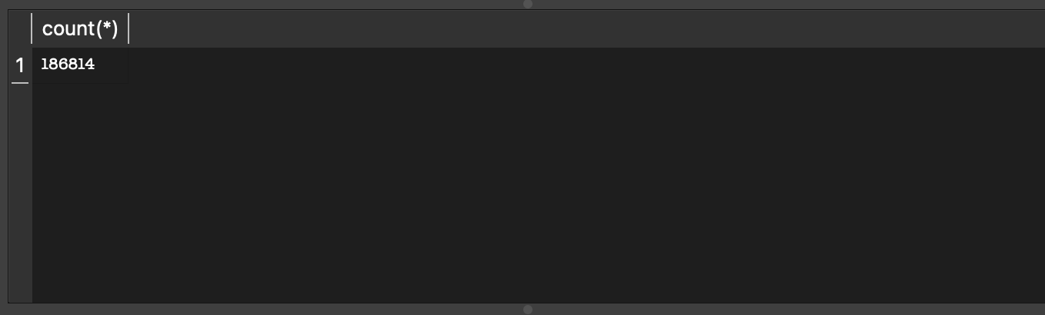
--2. Real average range, excluding the missing/zero placeholder values
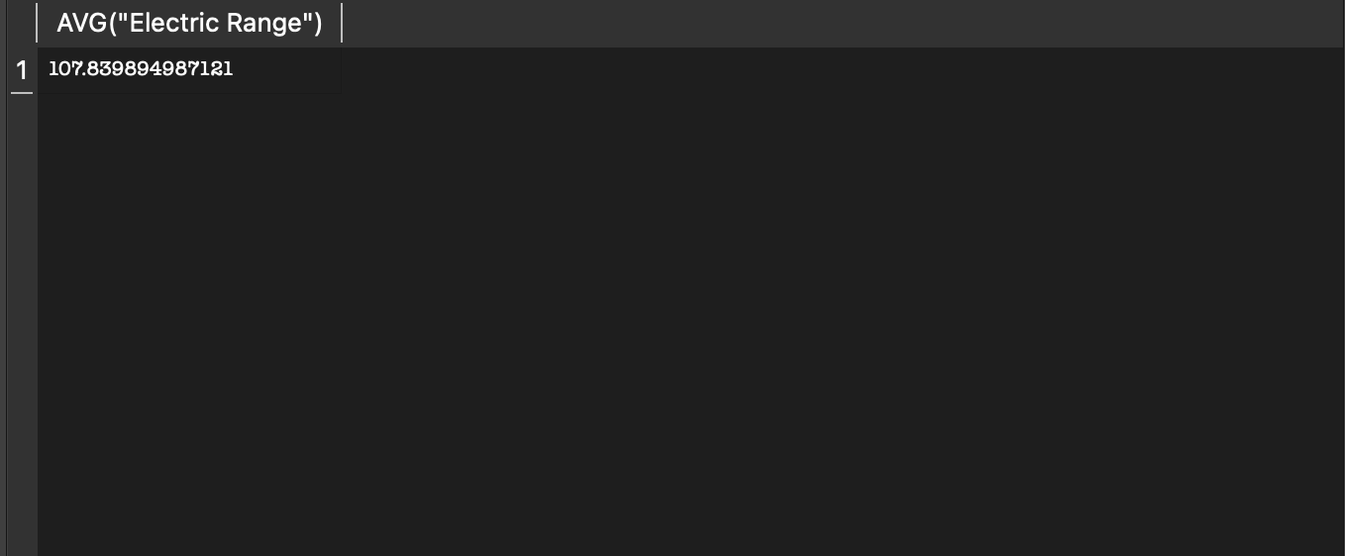
--3. Check for duplicate VIN prefixes (expected — shared model/trim, not errors)
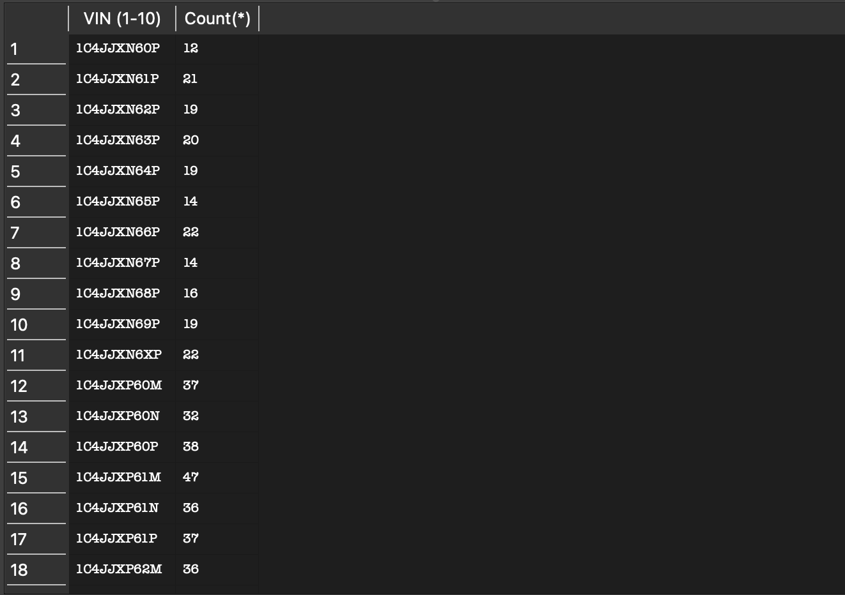
--4. Total brands - 48
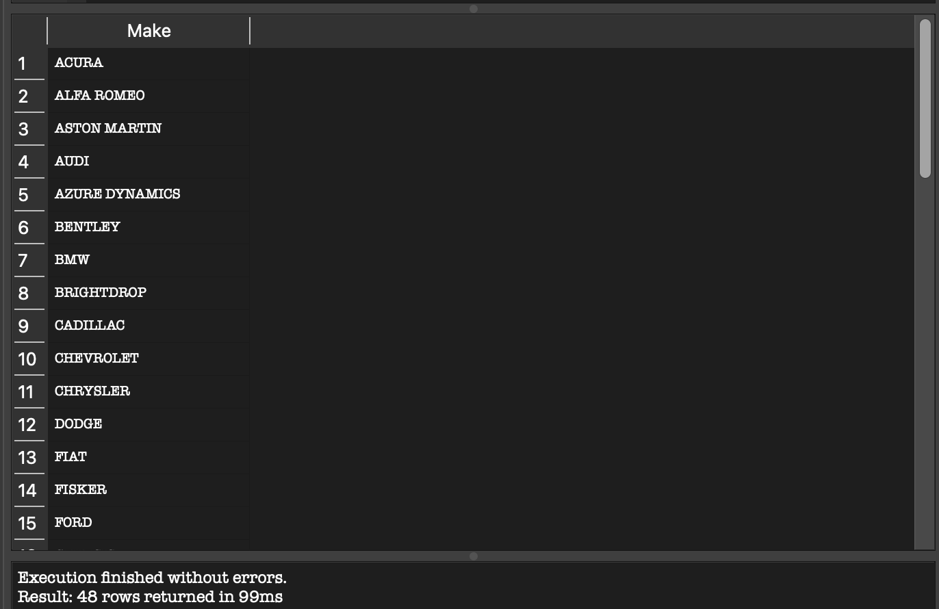
--5. Minimum and Maximum year model car
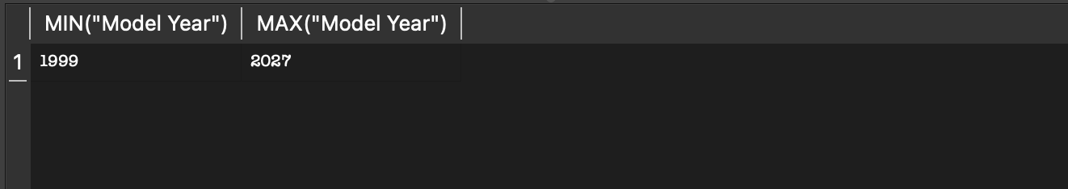
--6. Which makes the registered vechile and what is their average range?
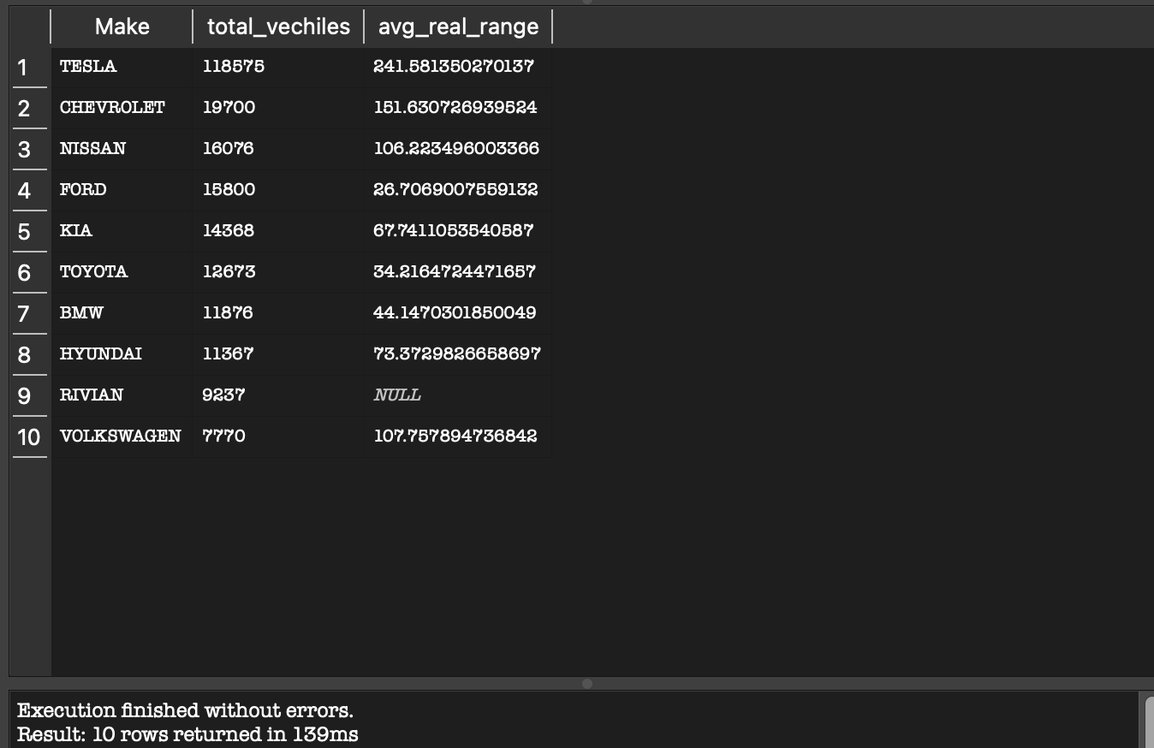
--7. Check if Rivian have electric range = 0


